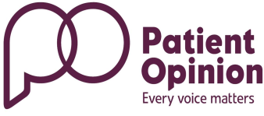
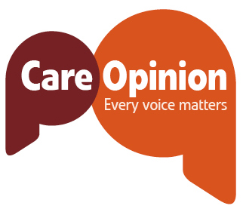
Student Nurse Opinion-Tell Your Story.

Who is Patient/Care Opinion?
PO/CO are fully integrated websites which publish stories about health and social care services and share them with the people that matter. Patient Opinion is an independent not for profit social enterprise.
This feedback can be viewed by the public to see what people think about their local service and allows the NHS, and all providers of health and adult social care to comment on the experience and make changes to improve the service that they provide.
College/  UNI |  | Date of Posting
Hospital/Service |  | Time Period for placement

Placement Location?
Type of Placement eg Mental Health 1st Year.

Email address
Patient Opinion needs your e mail so we can tell you when your posting is published or ask questions before publishing if necessary. The Patient Opinion Team will email to agree any edits or query if there are any moderation issues. Patient Opinion take steps to protect your identity where this might be an issue.
Important: We never reveal email addresses to anyone outside Patient Opinion.

Feedback about Placement:

- Observation about care
- Observation about learning environment.

.

